19.52: a)

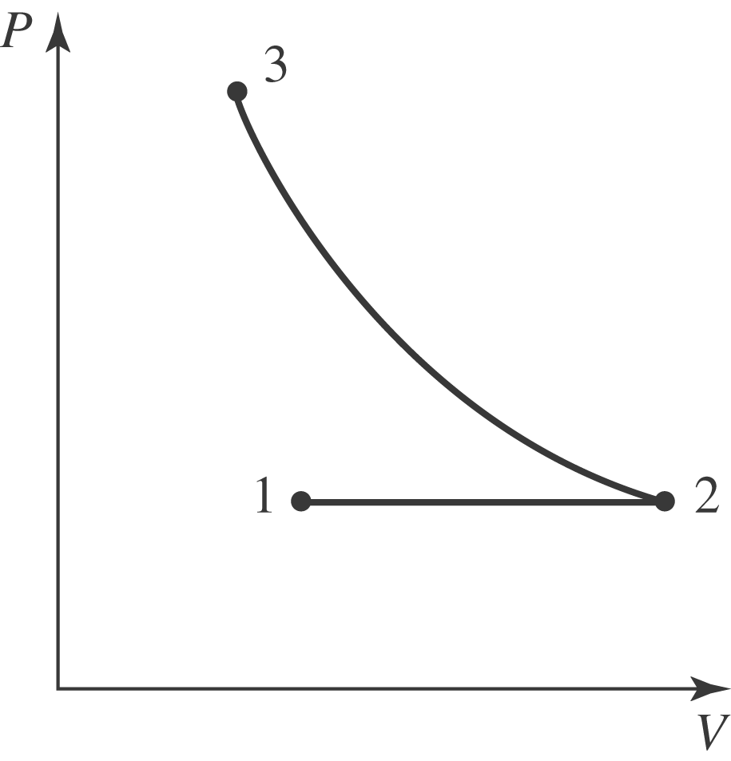
b) At constant temperature, the product pV is constant, so 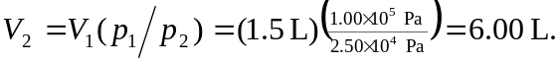 The final pressure is given as being the same as 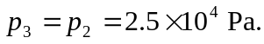 The final volume is the same as the initial volume, so 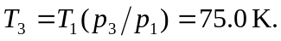 c) Treating the gas as ideal, the work done in the first process is

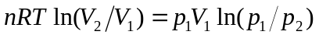
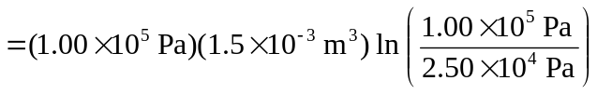
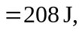

keeping an extra figure. For the second process,

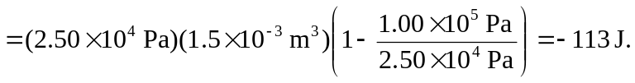

The total work done is 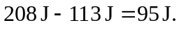 d) Heat at constant volume.

